Exercise 1:

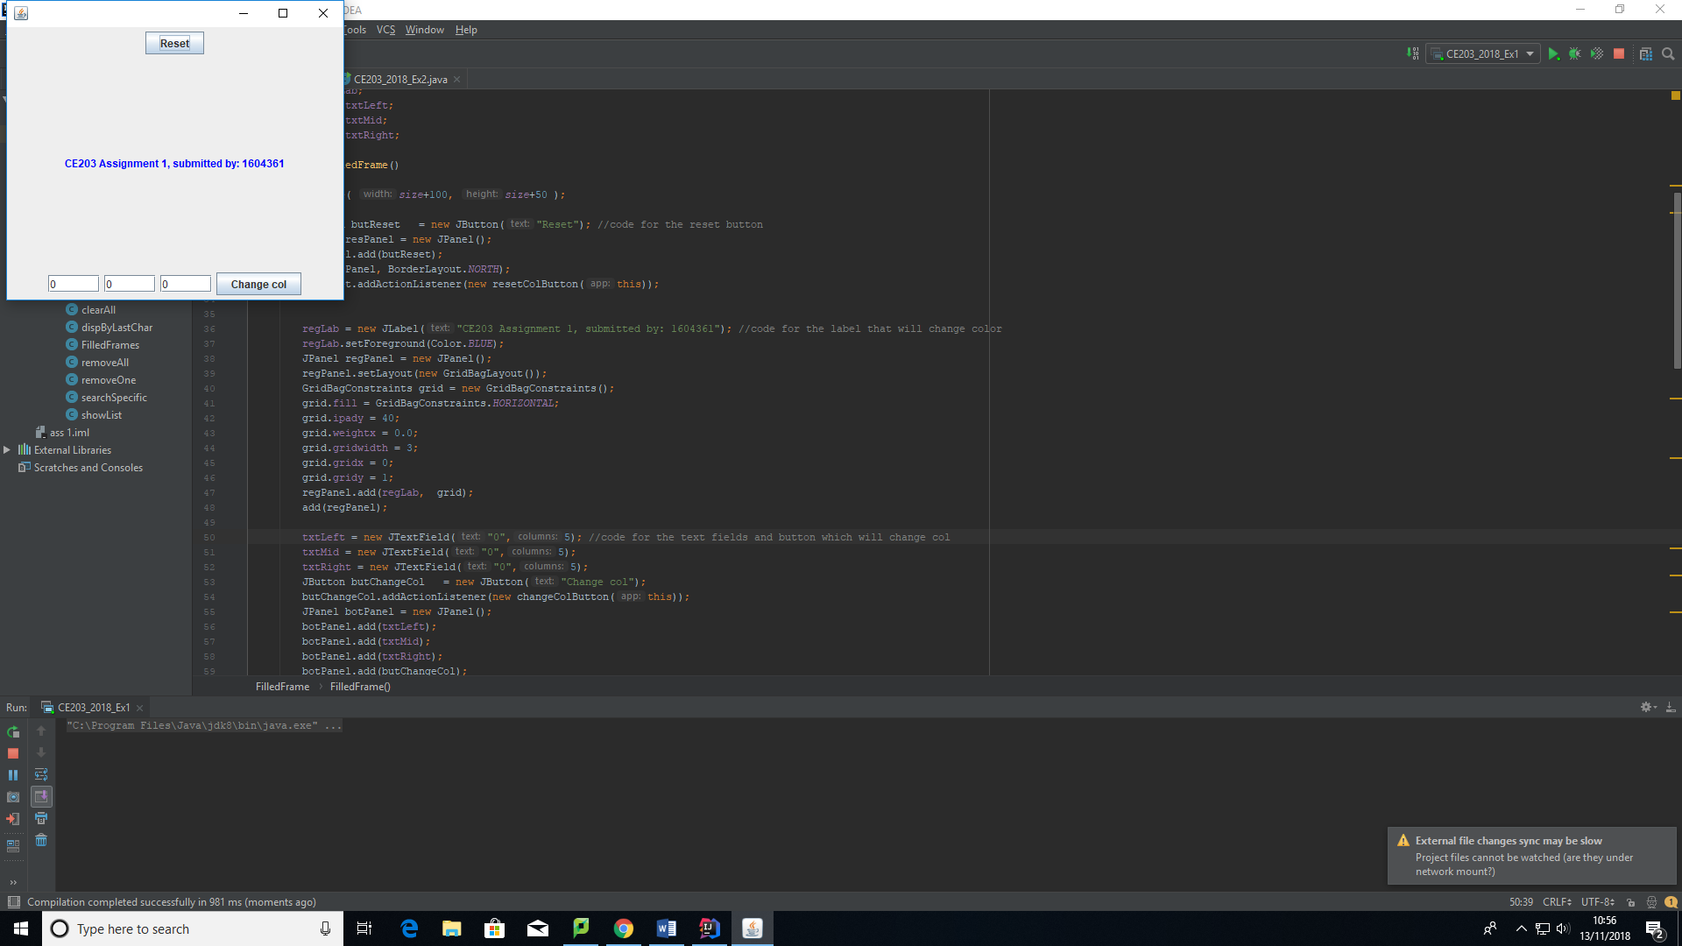

This is how the program looks when it’s run.

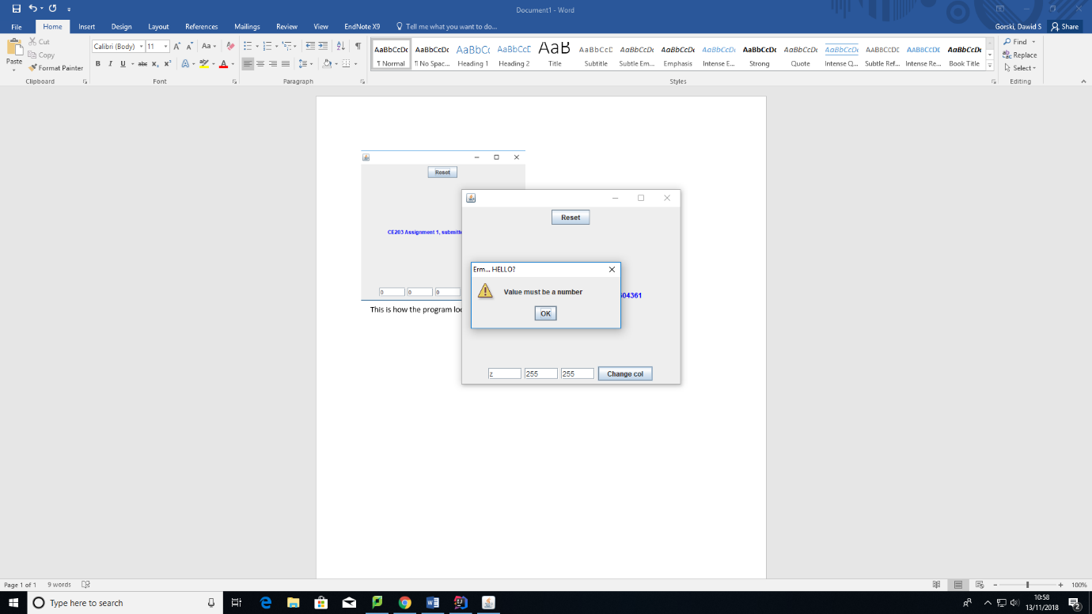

This is what happens when there is a letter instead of a number. It will then set that text box to 0.

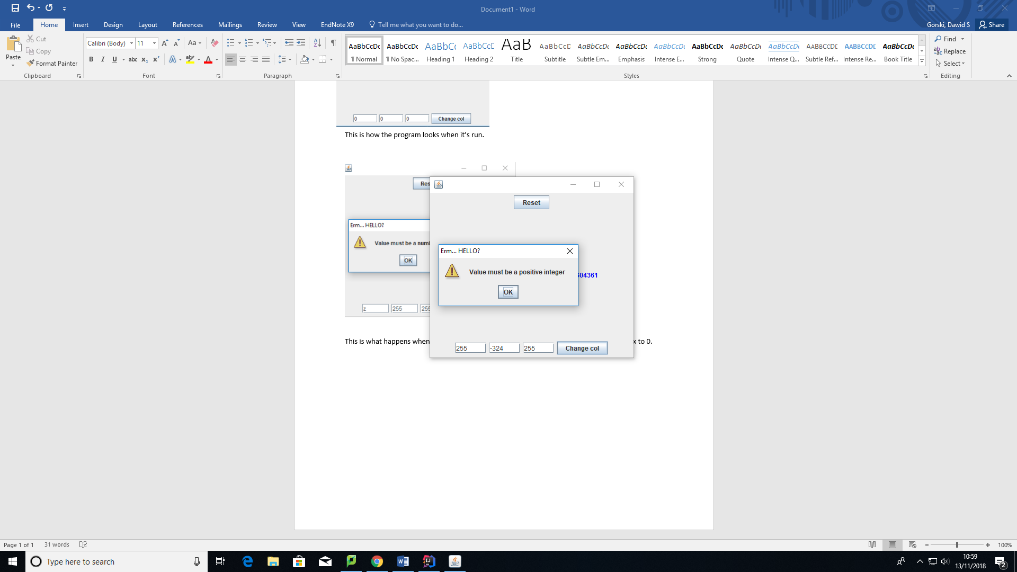

This is what happens when the value supplied to the text box is a negative integer. It will then clear that text box and set it to 200. It will only clear the middle text box.

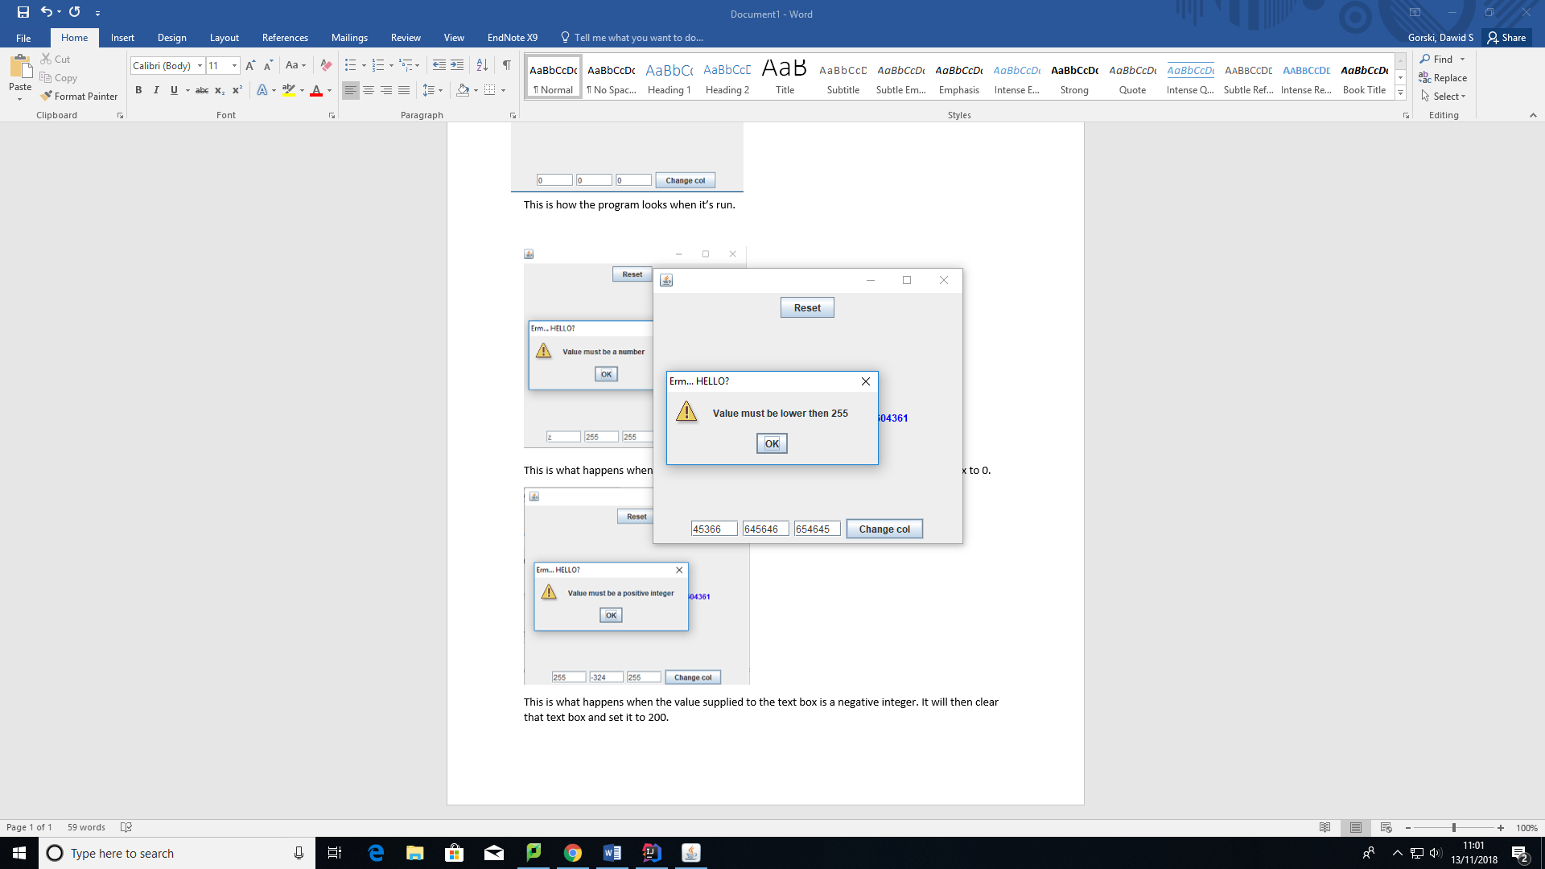

This is what happens if the values supplied are larger than 255. It will clear the text boxes and set their value to 255. Here it will clear all of them since all are larger then 255, but if any of them were an acceptable value (0-255) then it wouldn’t be cleared.

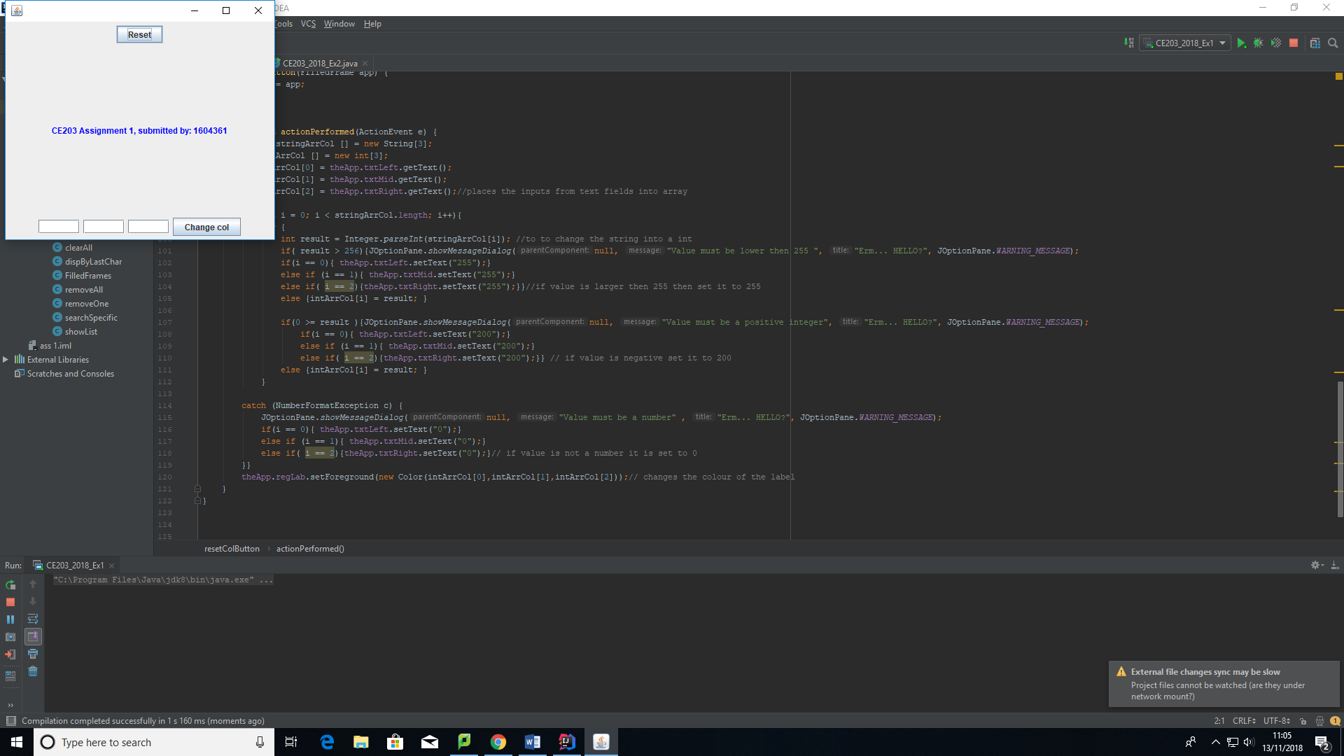

When the reset button is pressed, it will clear the text box fields, and change the text to the original colour (blue).

Exercise 2:

Adding a word to the list:

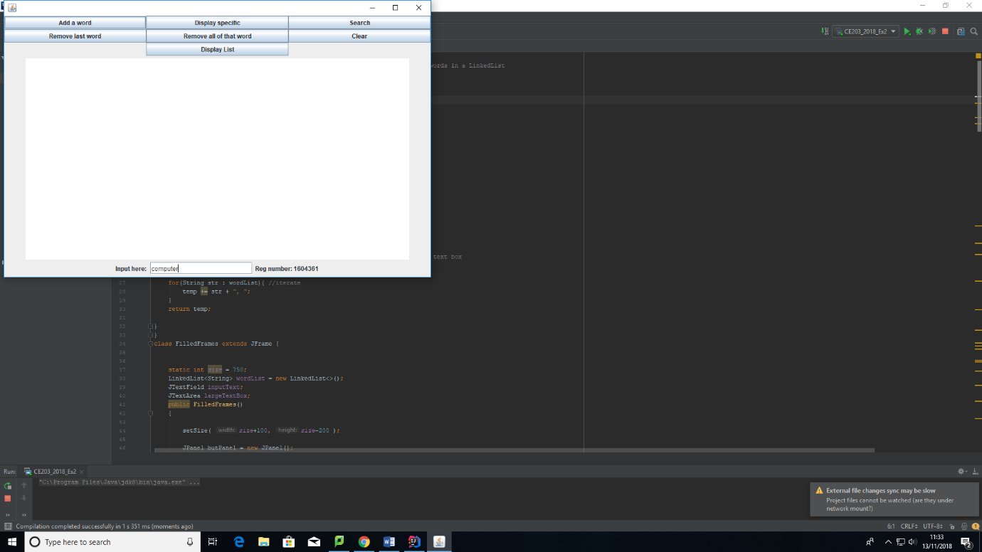Before button click:

After button click:

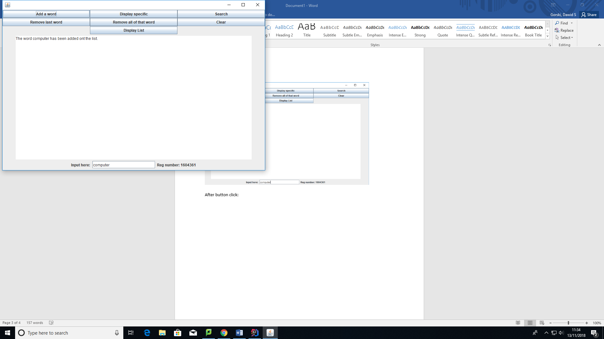

For the next tests I populated the list with the following inputs:

computer, computer, computer, computer, computer, computer, computer, sick, science, science, science, Java, Java, Java, sick, sick, cpp, cpp, cpp, cpp, Java, Java.

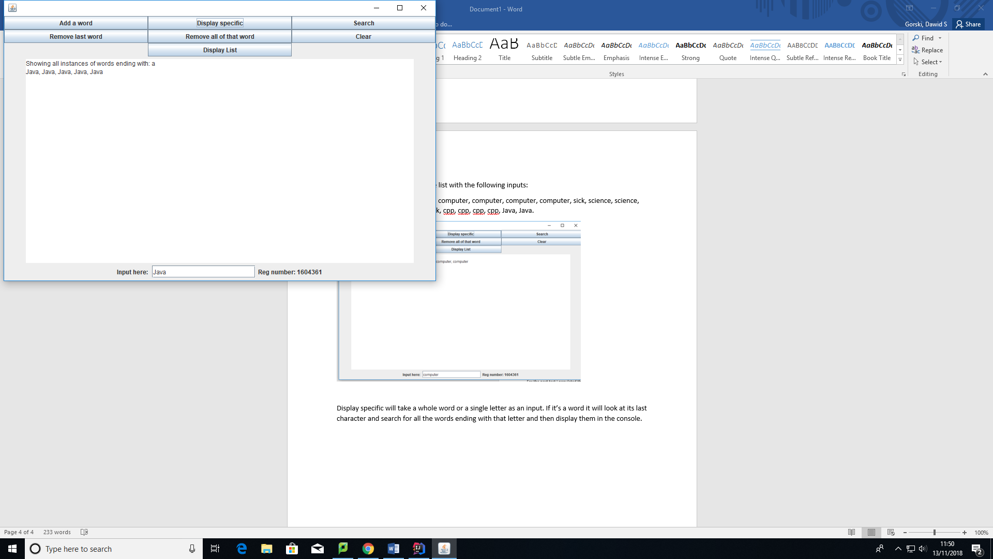

Display specific will take a whole word or a single letter as an input. If it’s a word it will look at its last character and search for all the words ending with that letter and then display them in the console.

Searching for a specific word: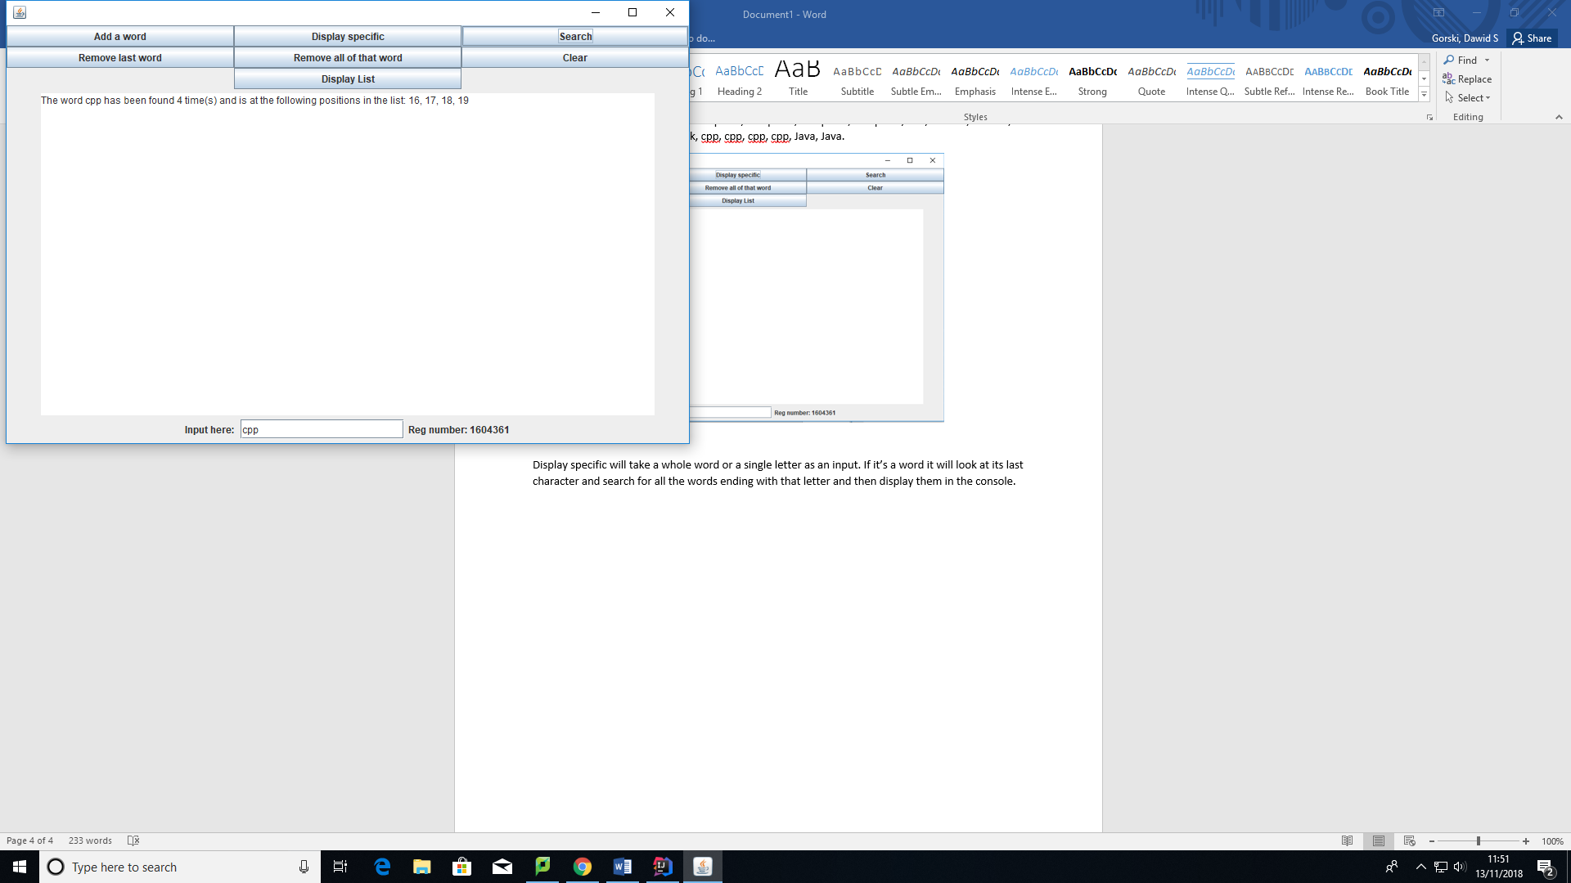

Here the app will loop through the list and store the positions of the matching word, then display them in the console.

Deleting the last word:

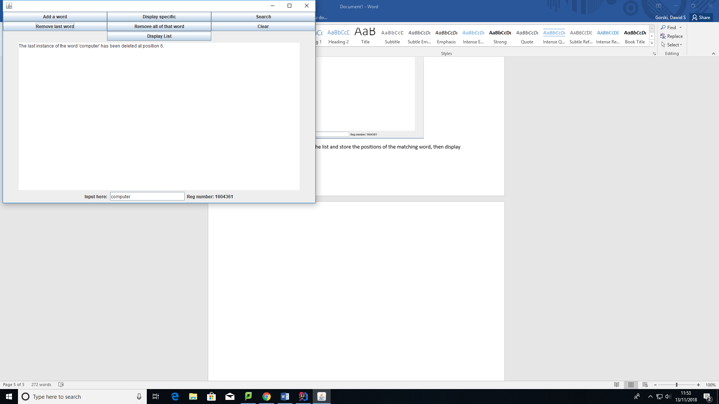

This will look at the supplied word, then it will look at the list, find its last position and then delete it.

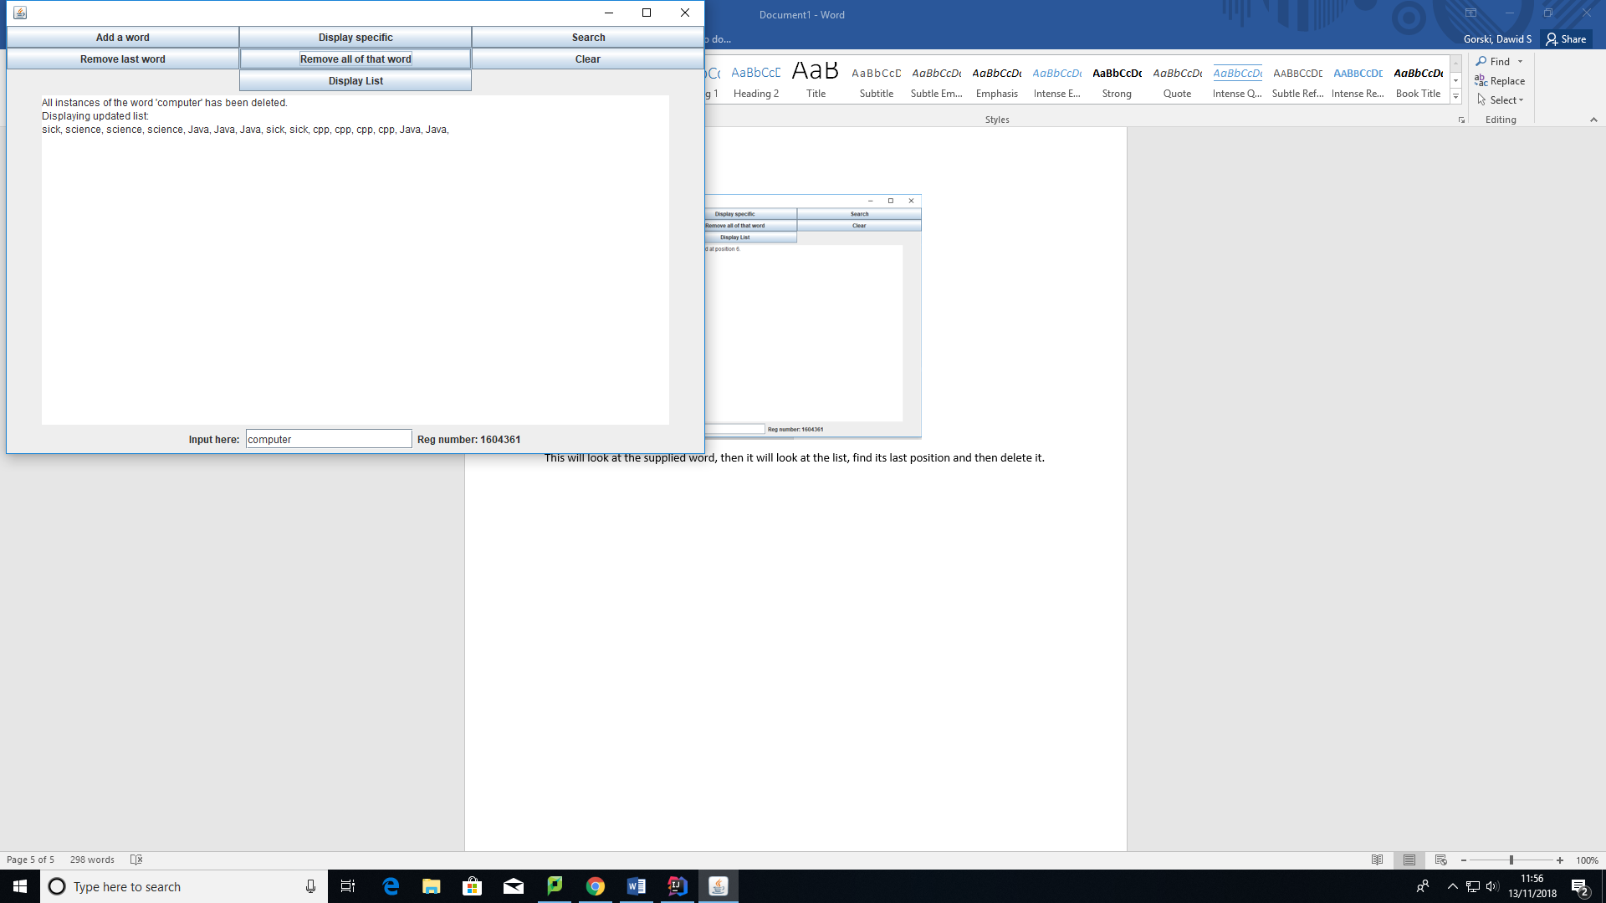

Here the word computer has been deleted from the list, then the updated list is being displayed. The app looks at the list, copies into a new list words that don’t match with the supplied word then it overrides the initial list with the new list.

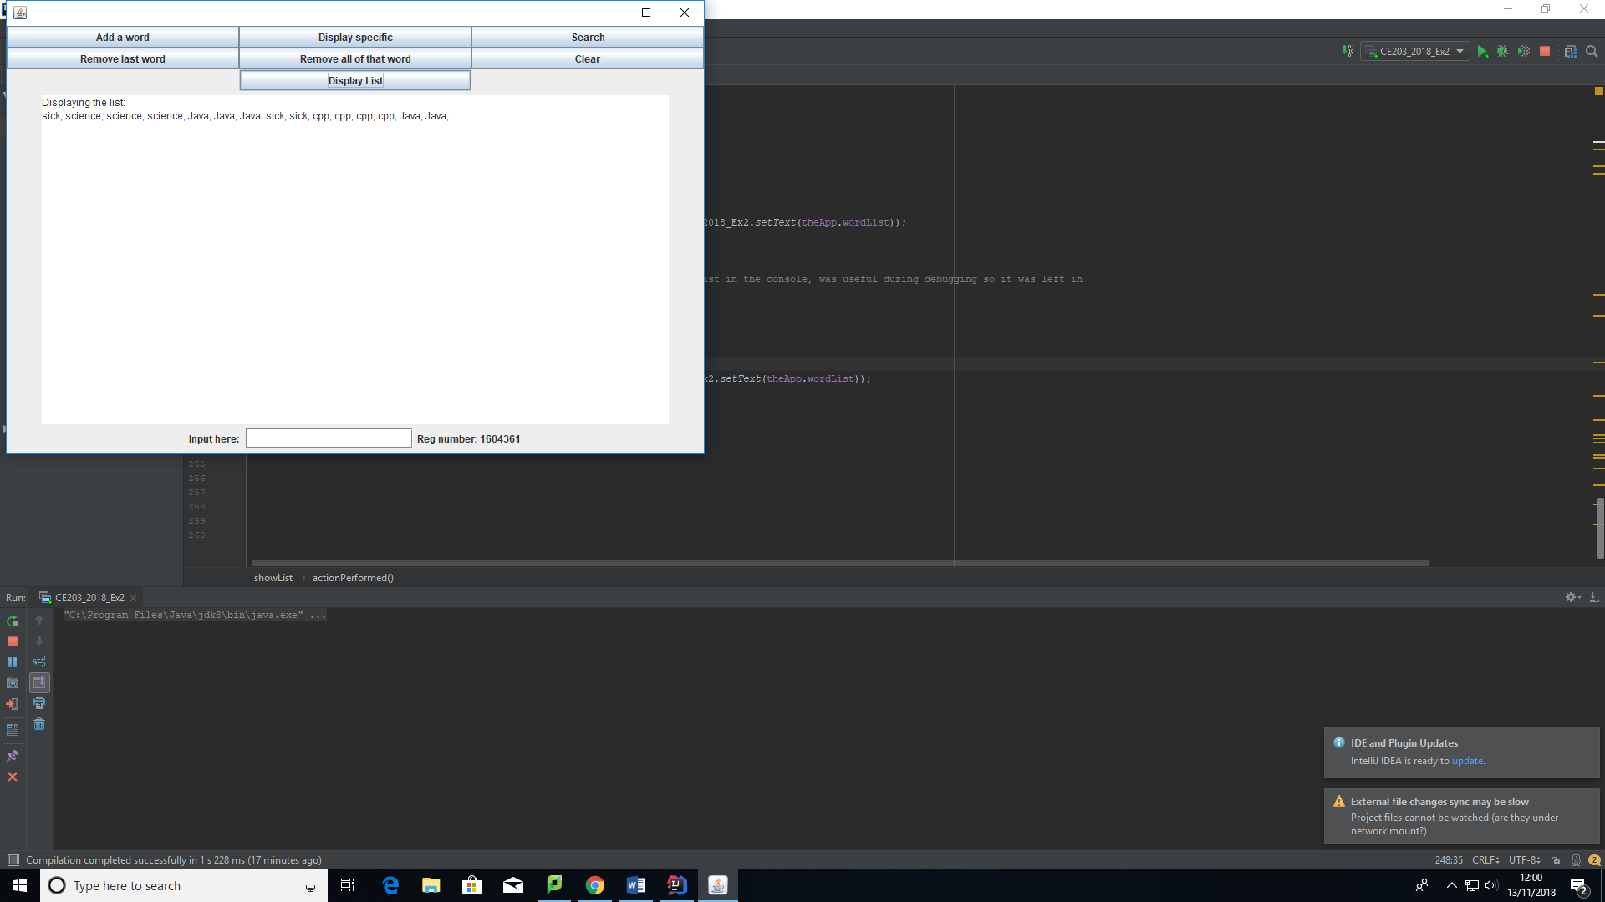

This is an extra bit I have added, it just displays the list in the console.